| Sl.  No. | Input  (n) | Algorithm-1  (Time by  frequency) | Algorithm-2  (Time by  frequency) | Algorithm-3  (Time by  frequency) |
| --- | --- | --- | --- | --- |
| 1 | 100 | 1433micorsec | 10331microsec | 3080microsec |
| 2 | 150 | 5425040micosec | 10041179microsec | 4396816microsec |
| 3 | 200 | 6204850microsec | 2168757microsec | 9693305microsec |
| 4 | 250 | 4600440microsec | 1981781microsec | 2892738microsec |
| 5 | 300 | 12300450microsec | 345512microsec | 5030206microsec |
| 6 | 350 | 333102microsec | 219594microsec | 2897048microsec |
| 7 | 400 | 2403499microsec | 198171microsec | 1742135microsec |
| 8 | 450 | 544422microsec | 2244208microsec | 749239microsec |
| 9 | 500 | 240399microsec | 1653923microsec | 1345375microsec |
| 10 | 550 | 701800microsec | 2064613microsec | 1032020microsec |

**Algo1:**

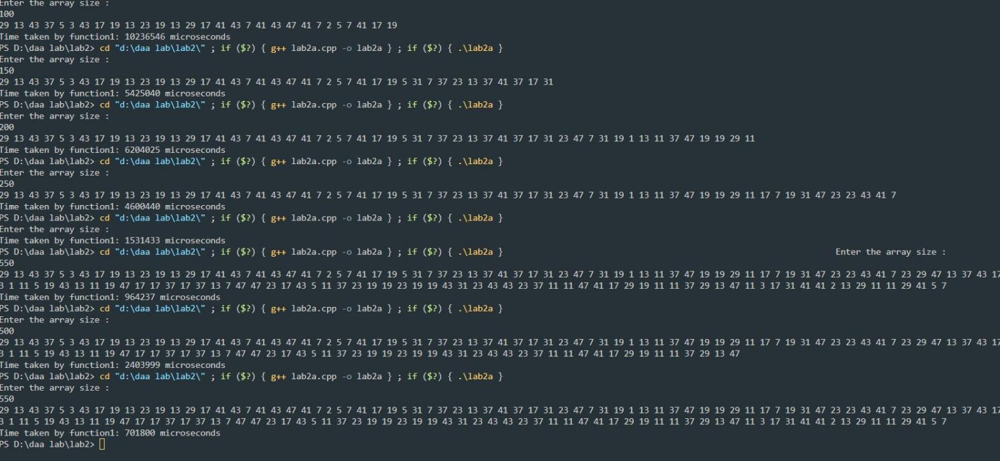

**Algo 2:**

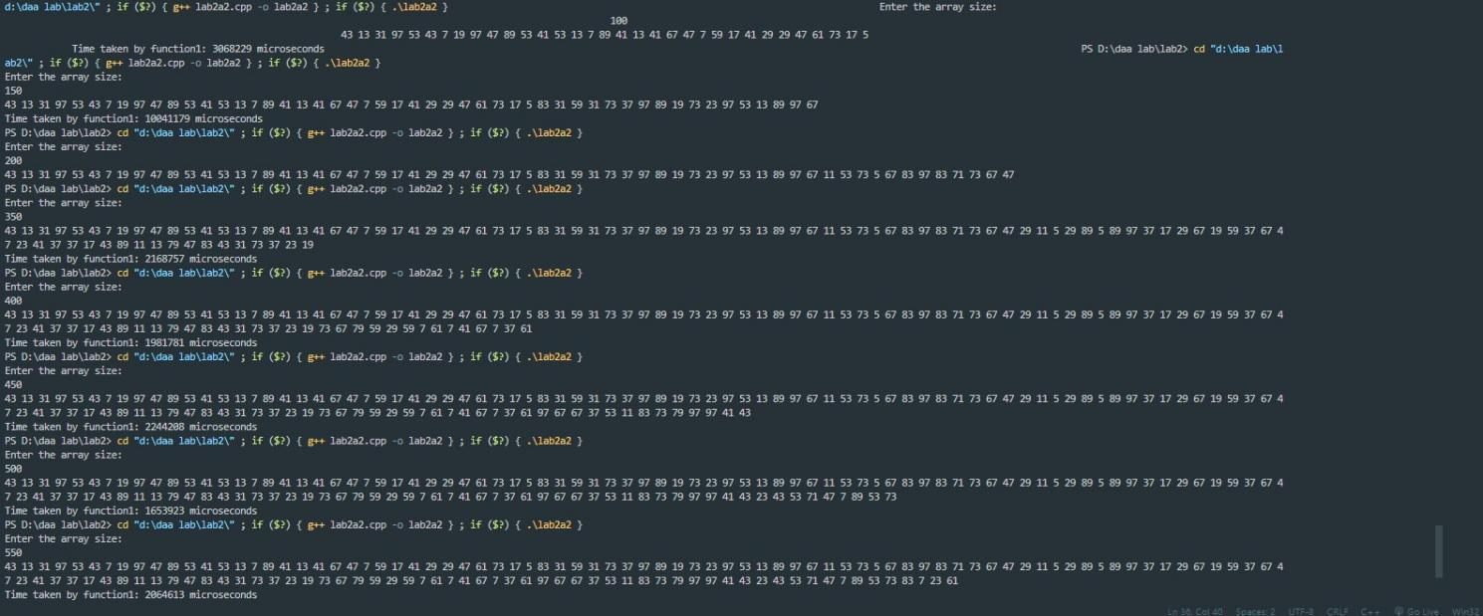

**Algo 3:**

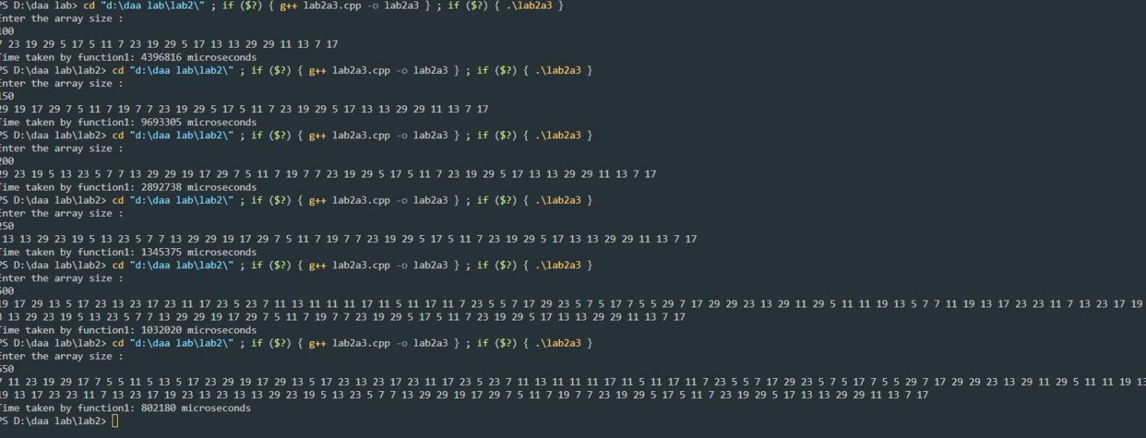

**Question 2:**

| **Sl.**  **No.** | **Input**  **GCD(x, y)** | **Euclid’s**  **algorithm**  **(Frequency**  **Count)** | **Consecutive**  **integer checking**  **algorithm.**  **(Frequency Count)** | **Middle school**  **procedure**  **algorithm**  **(Frequency Count)** | **Remarks**  **(Which one**  **Faster than**  **other two)** |
| --- | --- | --- | --- | --- | --- |
| **1** | **GCD**  **(31415, 14142)** | **237757micros** | **28215615**  **micros** | **18820787**  **mircos** | **first** |
| **2** | **GCD**  **(56, 32566)** | **1377448micros** | **9111519**  **micros** | **8218040**  **micros** | **third** |
| **3** | **GCD**  **(34218, 56)** | **11607583micro** | **11127985**  **micros** | **5625249**  **micros** | **second** |
| **4** | **GCD(12,15)** | **3712365micros** | **4099428**  **micros** | **3575020**  **micros** | **third** |
| **5** | **GCD**  **(31415, 31415)** | **19843640**  **micros** | **9591943**  **micros** | **12744020**  **micros** | **second** |
| **6** | **GCD (12, 12)** | **4309852micos** | **1575517**  **micros** | **2242216**  **micros** | **second** |

Algo 1:

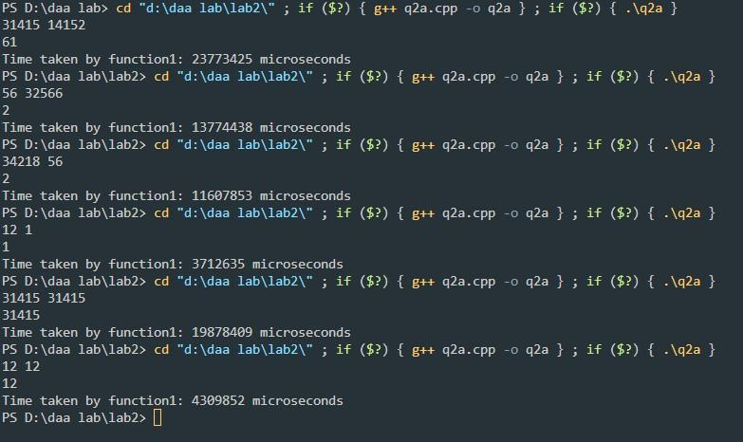

Algo2:

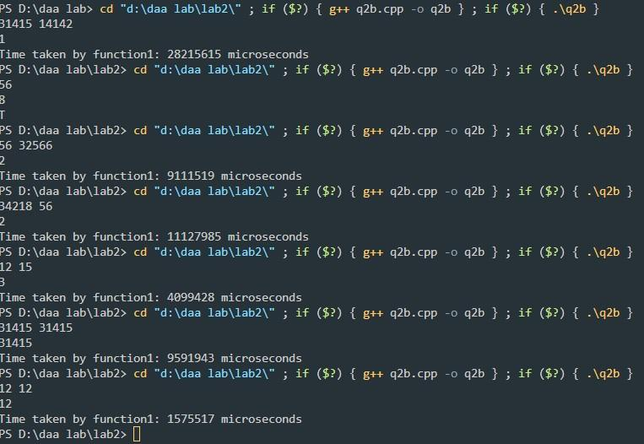

Algo 3:

